

***Manav Rachna University***

***Department of Computer Science & Technology***

DATABASE MANAGEMENT SYSTEM

***MINI PROJECT***

NAME:ROLL NO. :

**Saurabh Chahal 2K17CSUN01145**

**Mukul Singh 2K17CSUN01132**

BRANCH**: B.TECH(C.S.E.) Mrs. Gunjan Chandwani,**

SECTION**: 3-C Mrs Neelu Chaudhri**

**SYNOPSIS**

The system **COLLEGE MANAGEMENT SYSTEM**

can be used to manage the data of all type of educational institutes. It will support both stand alone and also networking environment. The system uses SQL. The main modules involved in this system are:

* ER diagram
* ER diagram to Tables
* Tables in database
* Insertion in tables
* Various DDL, DML Queries

**ABSTRACT**

An organized and systematic office solution is essential for all universities and organizations. There are many departments of administration for the maintenance of college information and student databases in any institution. All these departments provide various records regarding students. Most of these track records need to maintain information about the students. This information could be the general details like student name, address, performance, attendance etc or specific information related to departments like collection of data.

All the modules in college administration are interdependent. They are maintained manually. So they need to be automated and centralized as, Information from one module will be needed by other modules. For example when a student needs his course completion certificate it needs to check many details about the student like his name, reg number, year of study, exams he attended and many other details. So it needs to contact all the modules that are office, department and examination and result of students.

With that in mind, we try to develope Student Database Management System and made necessary improvement to streamline the processes. Administrators using the system will find that the process of recording and retrieving students information and managing their classes, including marking of attendance, is now a breeze. In general, this project aims to enhance efficiency and at the same time maintain information accurateness. Later in this report, features and improvement that allow achievement to this goal will be demonstrated and highlighted.

Our work is useful for easy user interface. We are planning to utilize the powerful database management, data retrieval and data manipulation. We will provides more ease for managing the data than manually maintaining in the documents. Our work is useful for saving valuable time and reduces the huge paper work.

Mini Project:

College management System database

**Er diagram**

**Person**

**Staff**

**Student**

**Alumnus**

**1**

**Study**

**M N**

**Faculty**

**Courses**

**N N M**

**Report**

**Works_in**

**N**

**Awards**

**M**

**Department**

**ER-diagram to Tables:**

**Person:**

|  |  |  |  |  |
| --- | --- | --- | --- | --- |
| **Name** | **SSN** | **Sex** | **Address** | **Birth_date** |

**Staff**

|  |  |  |  |  |  |
| --- | --- | --- | --- | --- | --- |
| **Name** | **SSN** | **Sex** | **Sadd** | **SBOD** | **Sal** |

**Alumnus**

|  |  |  |  |  |  |
| --- | --- | --- | --- | --- | --- |
| **Aname** | **Assn** | **Year** | **Deg** | **Major** | **Degrees** |

**Student**

|  |  |  |  |  |  |  |
| --- | --- | --- | --- | --- | --- | --- |
| **Name** | **SSN** | **Sex** | **SADD** | **SBOD** | **Fees** | **Class** |

**Courses Awards**

|  |  |
| --- | --- |
| **CID** | **CName** |

|  |  |  |
| --- | --- | --- |
| **AWID** | **AWname** | **AW_from** |

**Department Works_in**

|  |  |  |
| --- | --- | --- |
| **Dno** | **Dname** | **Fac_no** |

|  |  |  |  |
| --- | --- | --- | --- |
| **SID** | **Sname** | **Dno** | **Post** |

|  |  |  |  |
| --- | --- | --- | --- |
| **SID** | **AWID** | **Year** | **Perform** |

|  |  |  |
| --- | --- | --- |
| **CID** | **SSN** | **Class** |

**Faculty Report**

|  |  |  |  |  |
| --- | --- | --- | --- | --- |
| **Stud** | **Sname** | **Major** | **Minor** | **Attendance** |

**Study**

**Create database**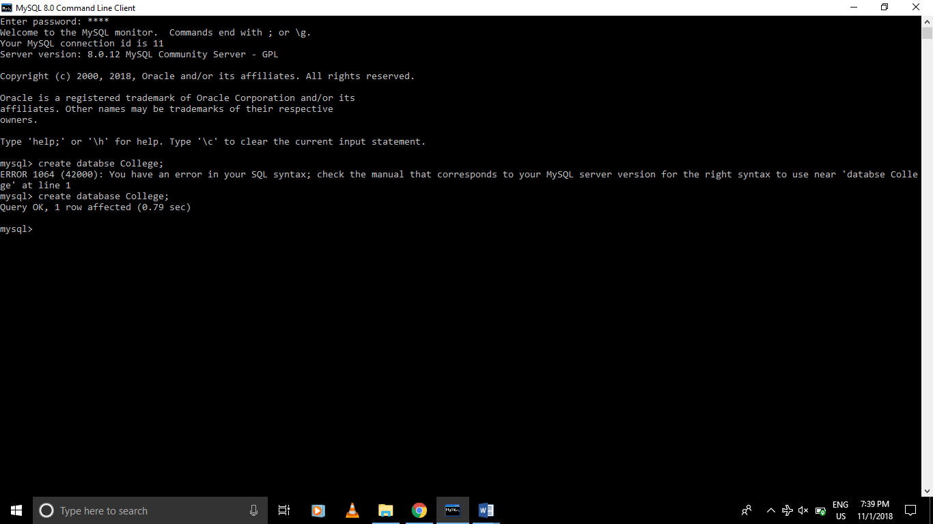

**Creation of tables**

**Person**

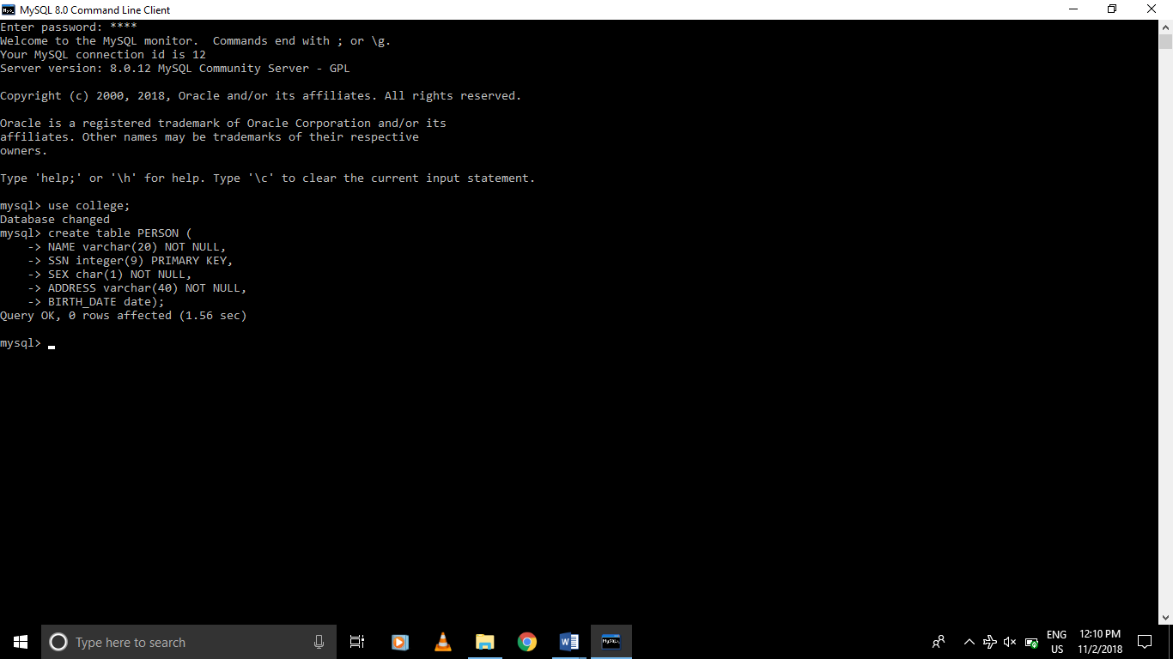

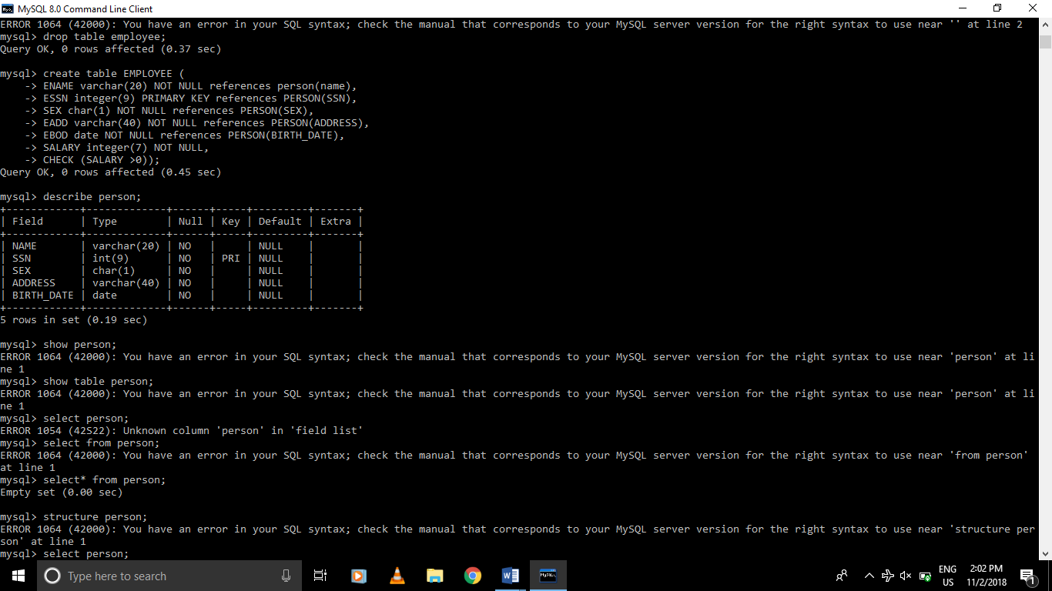

**Alumnus**

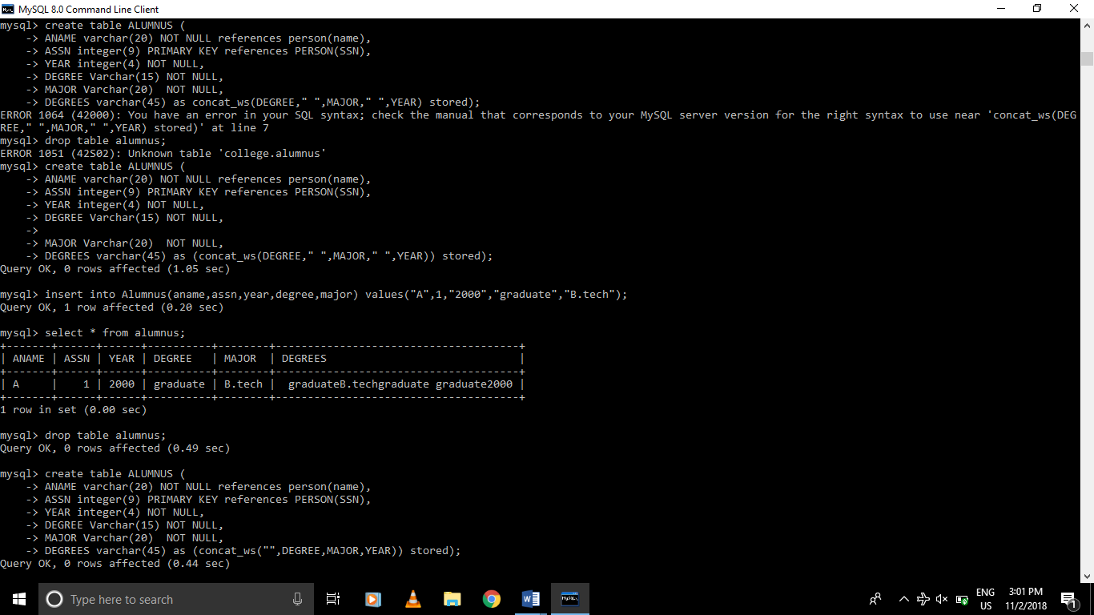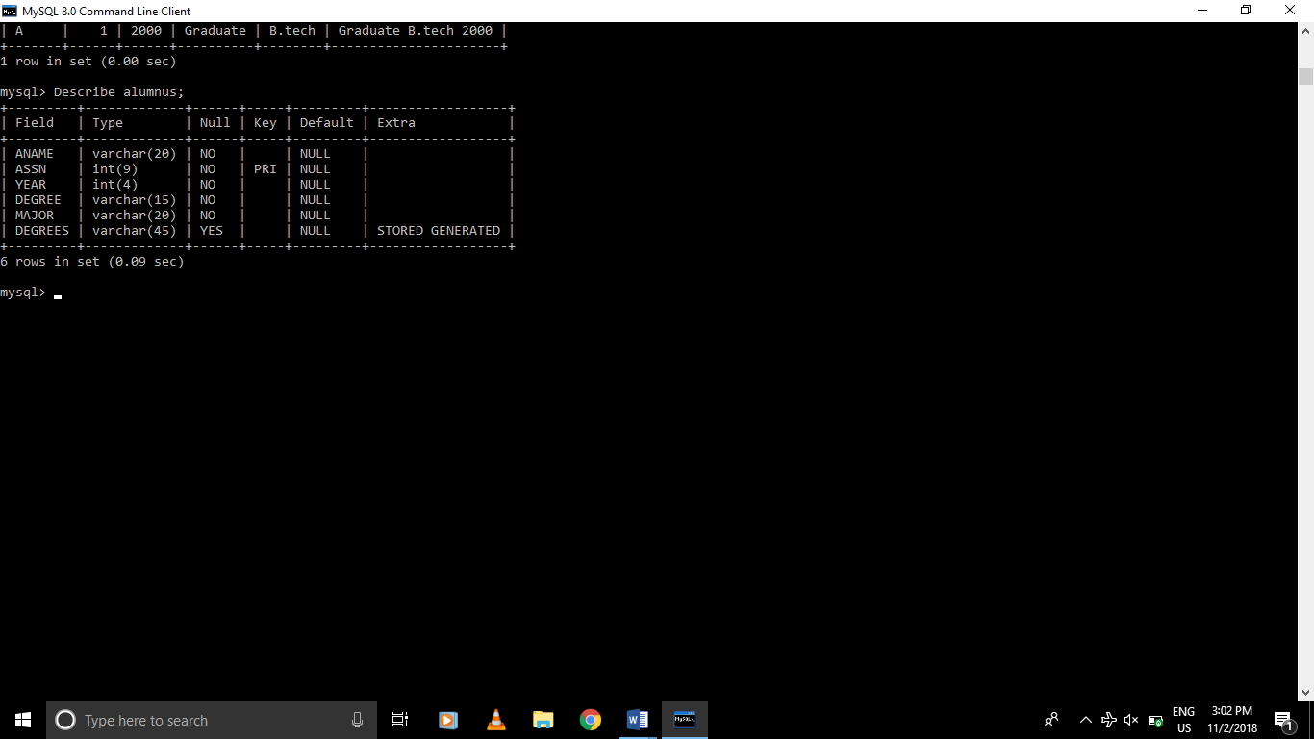

**Department**

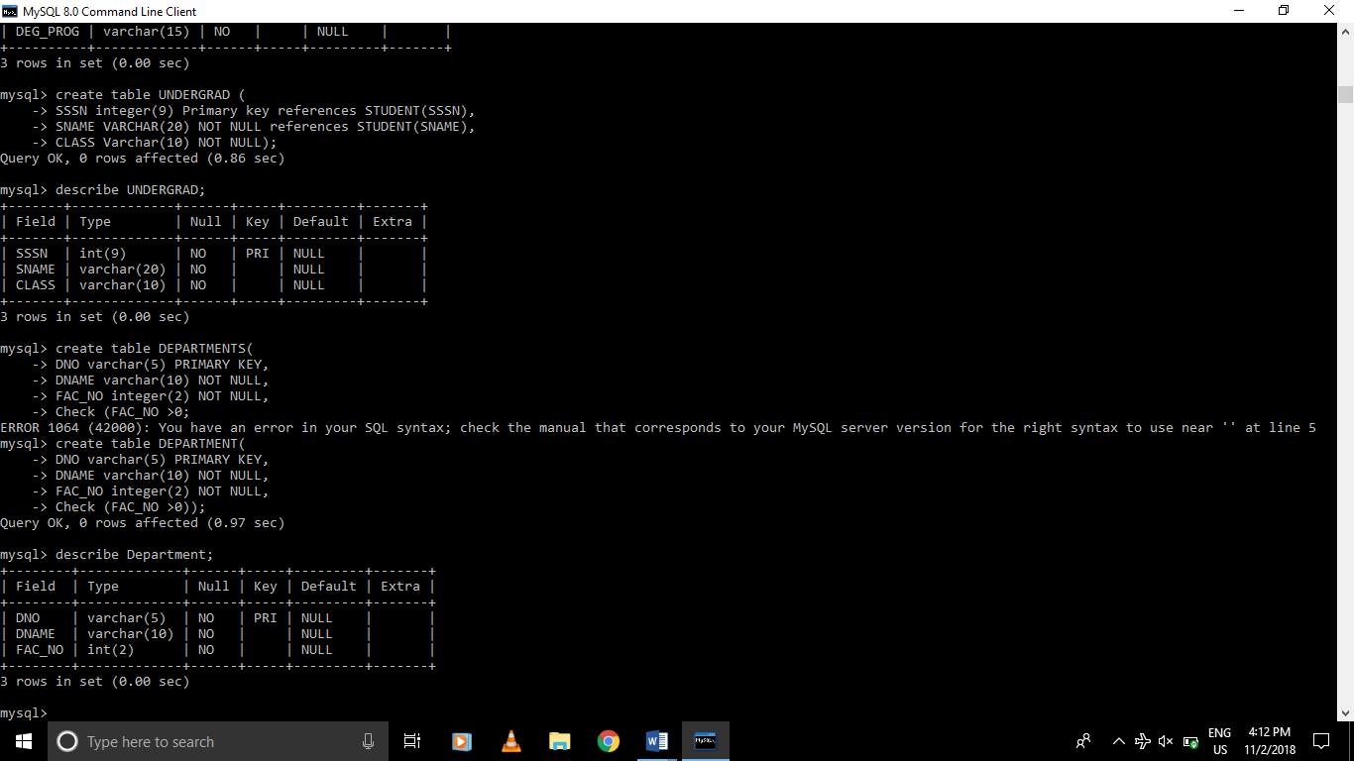

**Courses**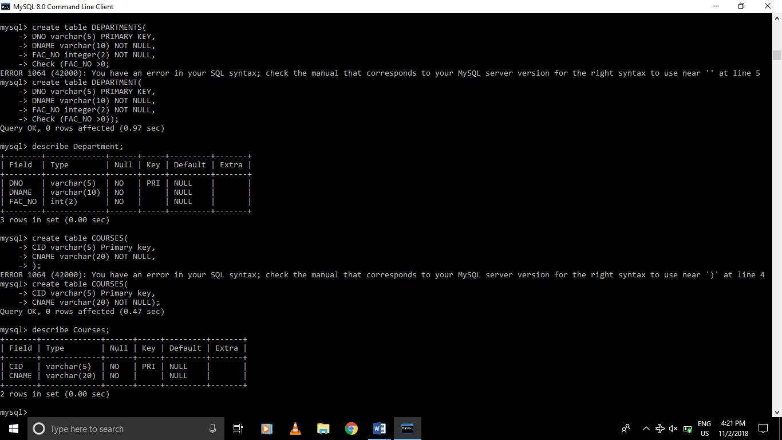

**Awards**

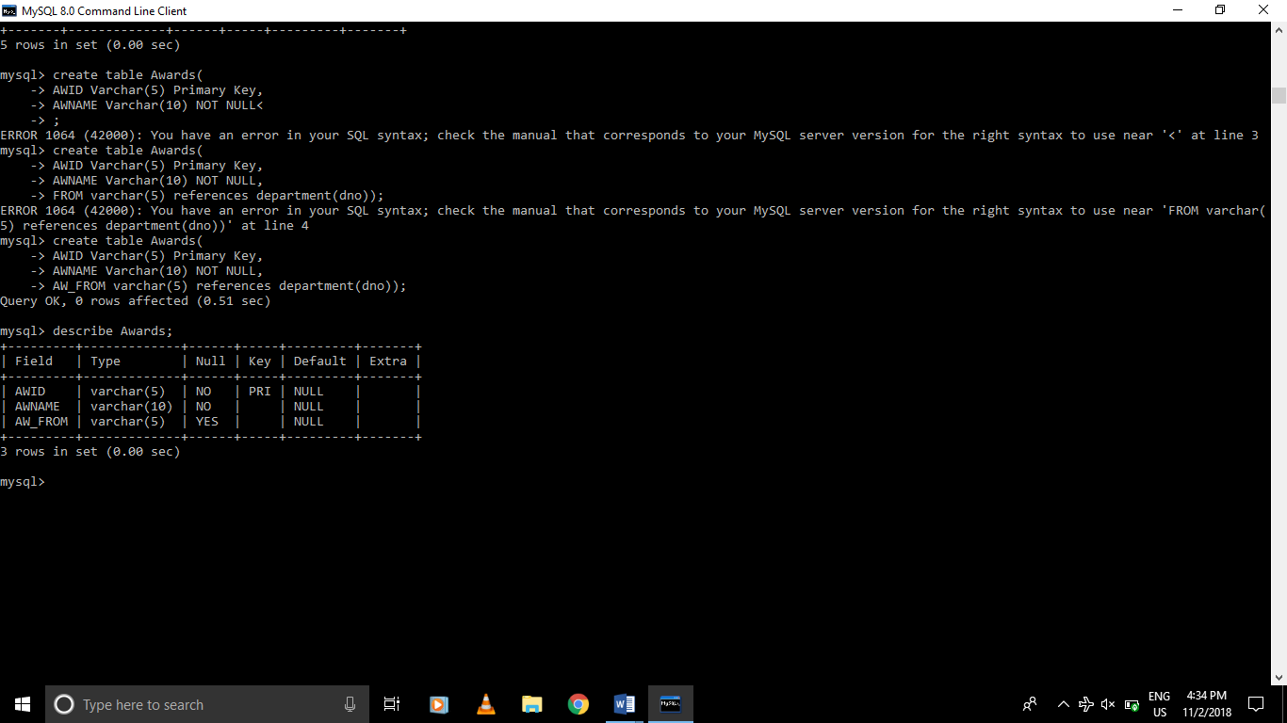

**Staff**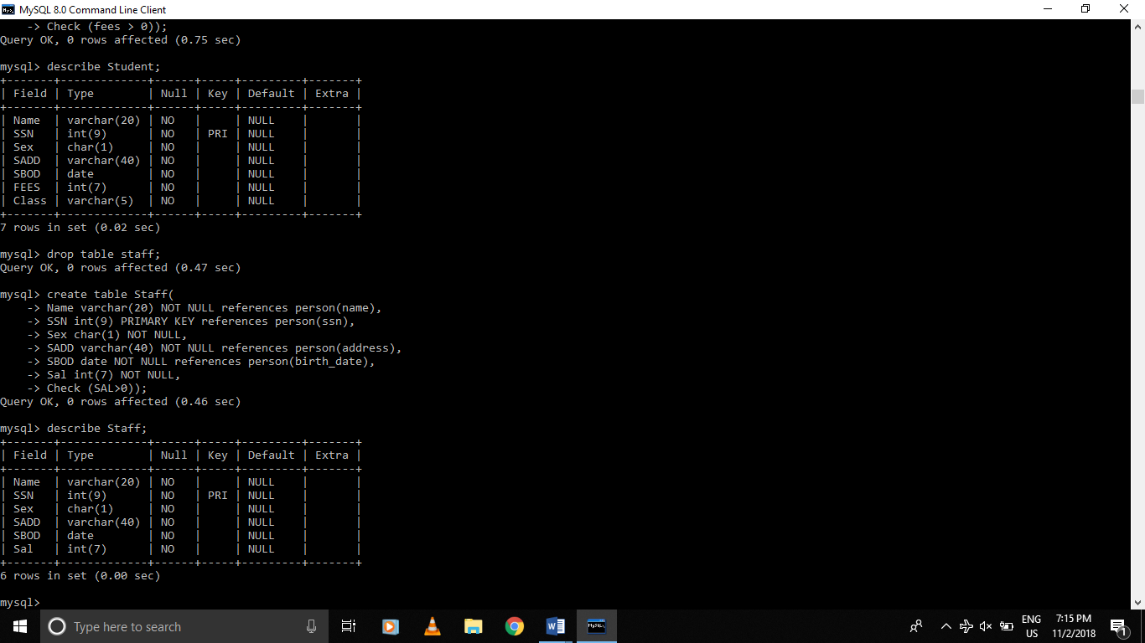

**Student**

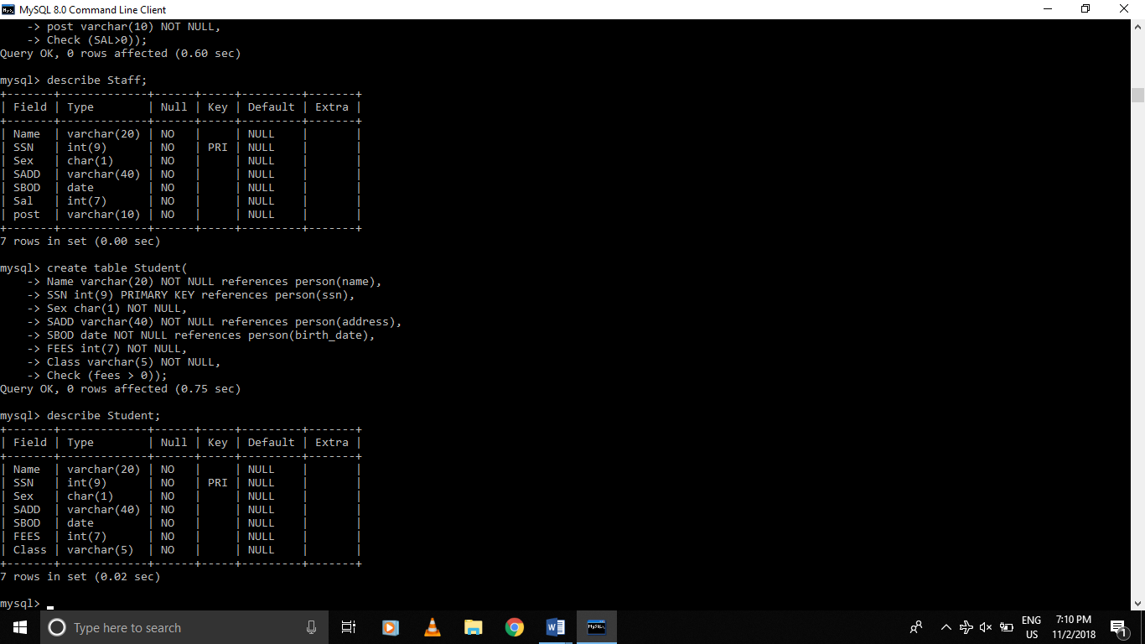



**Works_in**

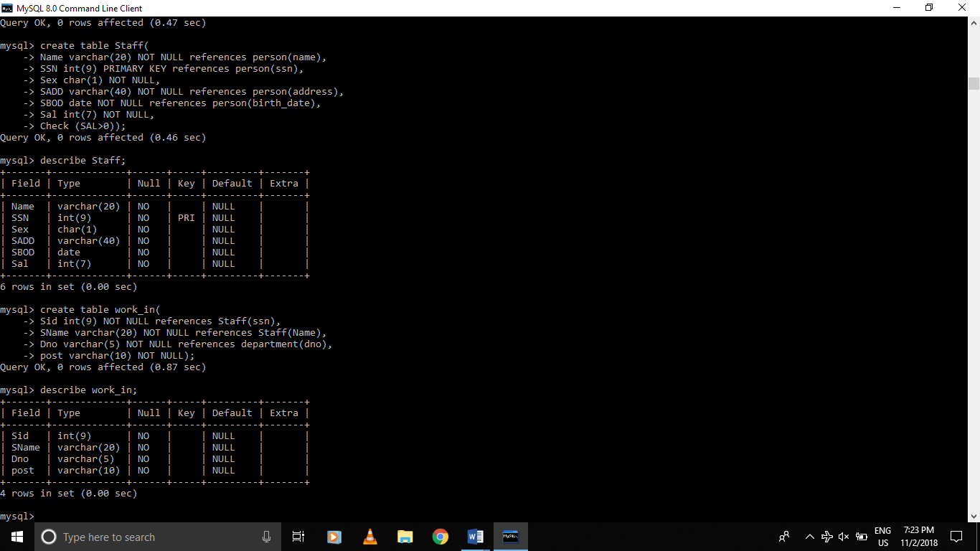

**Report**

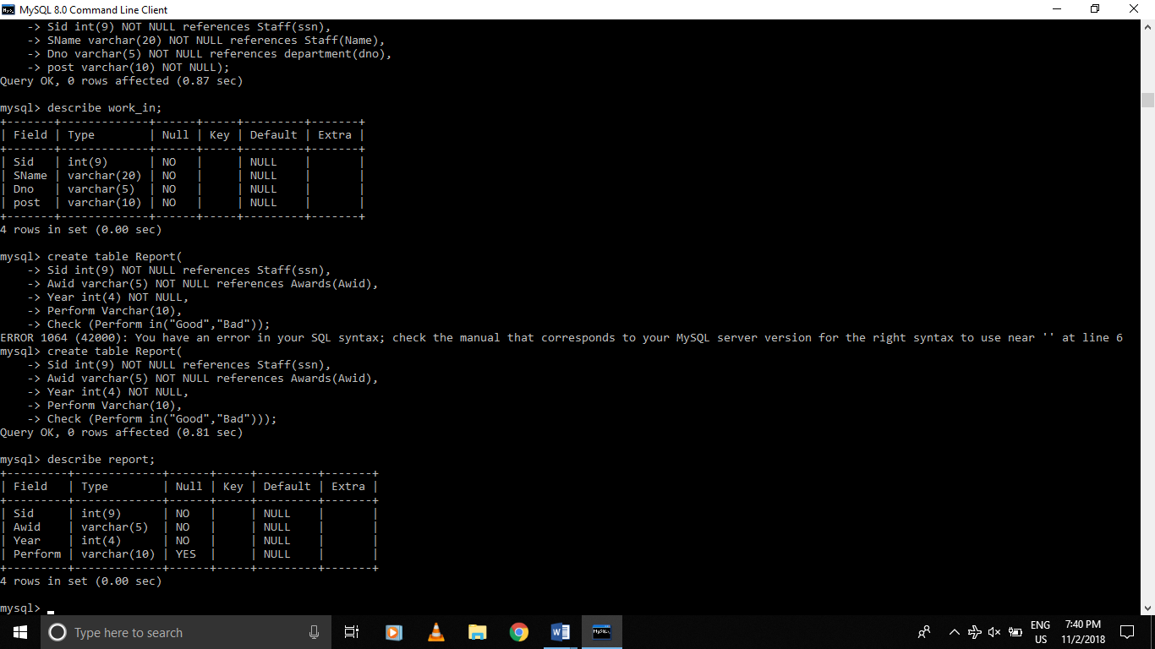

**Faculty**

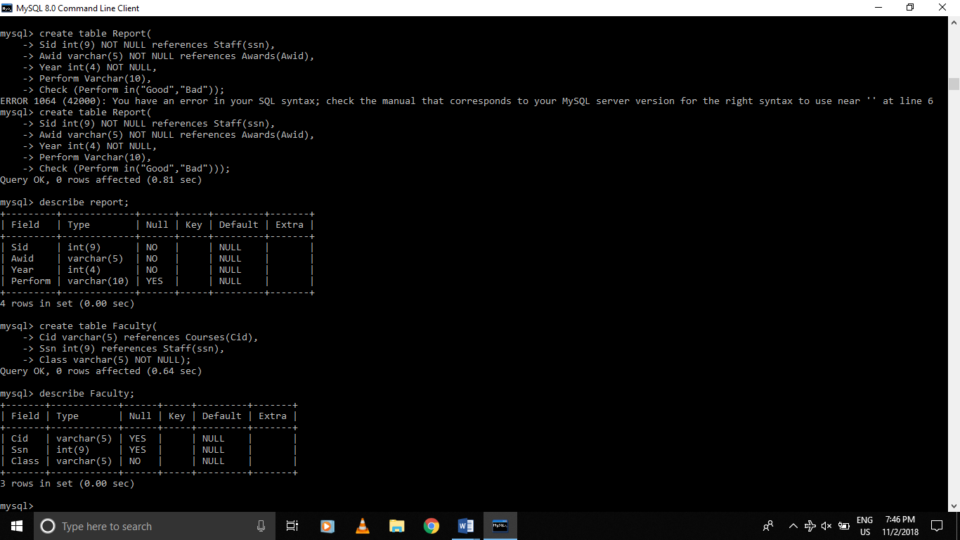

**Study**

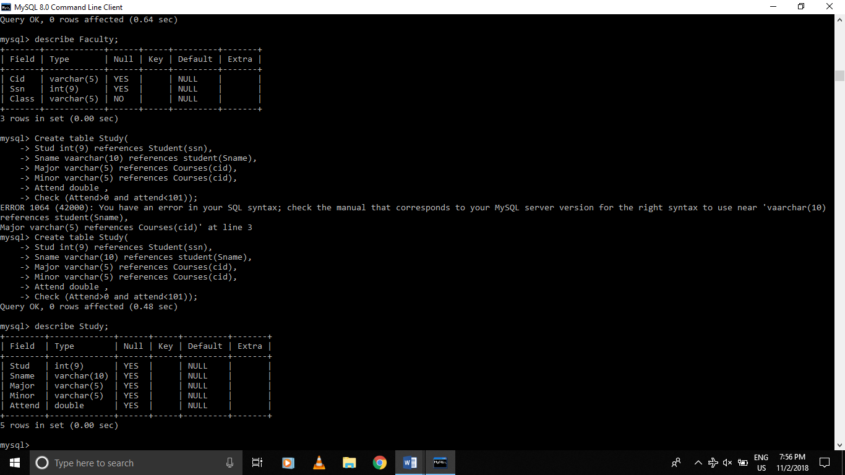

## Development of DDL, DML and Database Queries to achieve the following functionalities

## Enter, modify, delete staffs details:

## Insertion-

## 

## Modification-

## 

## Deletion –

## 

## Enter, modify, delete course details

## Insertion-

## 

## Modification-

## 

## Deletion-

## 

## Enter, modify, delete department details

## Insertion-

## 

## Modification-

## 

## Deletion-

## 

## View details of all staffs category wise, location wise, programme wise etc.

## Location wise:

## 

## Department wise:

## 

## View details of all student categories wise, location wise, programme wise etc.

## Ans-

## 

## Course Wise:

## 

## View performance of staffs and their significant achievement year wise

## 

## Generate reports of detained students’ course wise.

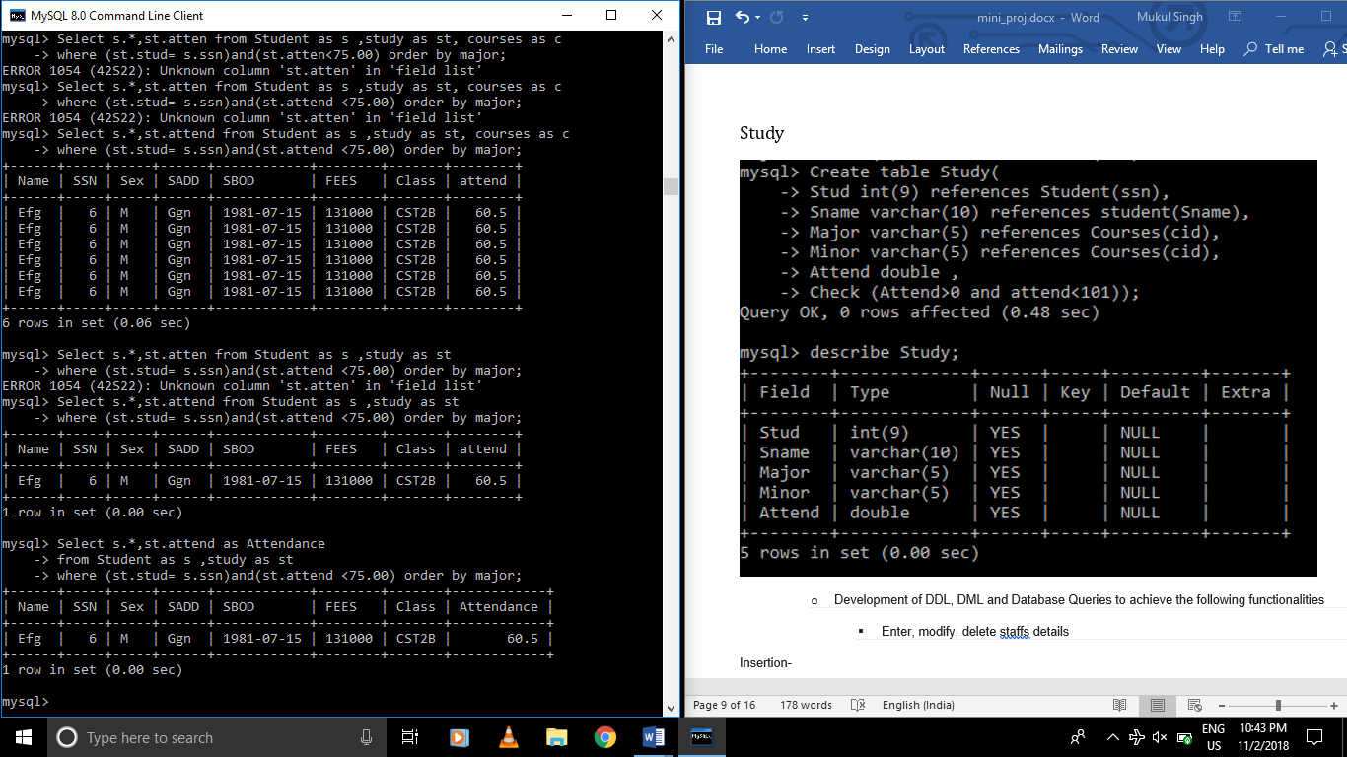

1. **Insertion in Alumnus (Special: Composite attribute)**

